Saad Bin Zahid
Sp24-BSE-153
Lab 3
JIRA (SCRUM Board-Sprints)
Here is the modernized version of the introductory section, updated to align with current Jira Cloud terminology, sidebar navigation, and modern Agile practices:

Lab 03: Modern Issue & Bug Tracking with Jira
Objective: The purpose of this lab is to understand how Jira is utilized as a versatile planning, tracking, and project management tool in modern software engineering. The focus of this lab is to familiarize students with Jira's robust issue and bug tracking capabilities, enabling them to effectively report, triage, manage, and track defects across the software testing lifecycle.
Activity Outcomes:
- Comprehensive understanding of Jira as a leading enterprise bug-tracking and Agile project management tool.
- Practical ability to write detailed bug reports, configure workflows, and track defects for any software product.
Instructor Note & Useful Concepts:

Introduction to Jira
Modern Jira is an expansive, AI-driven developer and project management platform that goes far beyond basic bug tracking. It features built-in AI for drafting descriptions and writing queries, no-code automation rules, and native two-way synchronization with GitHub, GitLab, and CI/CD pipelines so issues update automatically as code is merged. Additionally, it combines flexible Scrum and Kanban boards with interactive project timelines for comprehensive agile planning.

Key capabilities include:
- Backlog Management: Creating, refining, and prioritizing product backlogs containing epics, user stories, tasks, and bugs.
- Sprint Planning: Structuring and executing time-boxed iterations (sprints) to deliver incremental product value.
- Issue Tracking: Managing diverse work items (bugs, tasks, improvements, and stories) with customizable fields, attachments, and comments.
- Workflow Management: Transitioning issues through custom statuses (e.g., To Do, In Progress, In Review, Done).
- DevOps & Tool Integration: Seamlessly integrating with version control systems (like GitHub and GitLab), CI/CD pipelines, and team communication apps (like Slack).
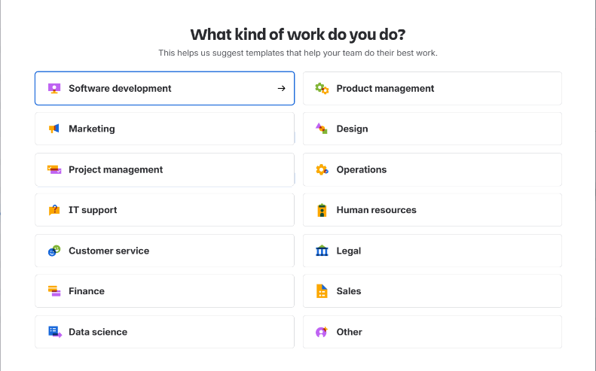

Epics, Stories, and Subtasks
To break down a big project into smaller pieces, Jira uses a hierarchy of issues:
- Epic: A big goal or a large project chunk that contains smaller pieces of work.
- Story: A smaller piece of work taken from an Epic, representing a specific feature or requirement.
- Child Issue (Subtask): The smallest task possible, used to divide a story into step-by-step technical actions.
What's New in Modern Jira:
Modern Jira lets teams create flexible issue types and offers AI tools that can automatically suggest subtasks or help write better descriptions for your stories.

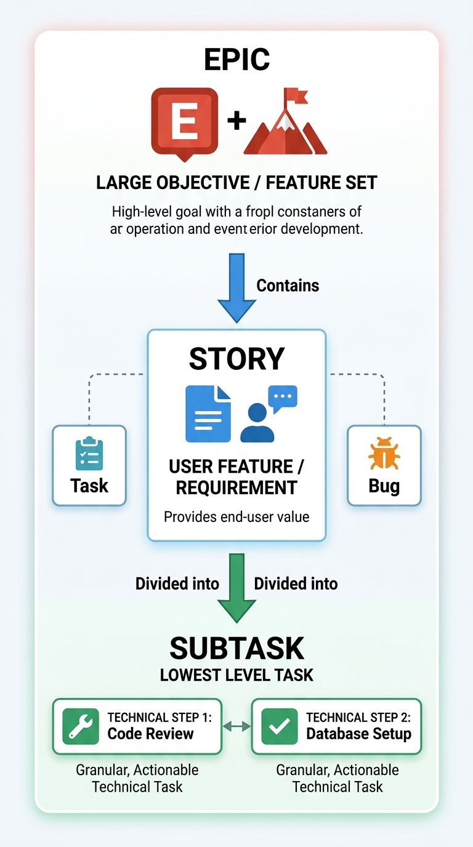

Agile Process Methodology
Agile is a flexible, step-by-step approach to building software. Instead of waiting until the very end to deliver a massive product, Agile delivers working pieces of the product bit by bit. Its main focus is teamwork, quick feedback, and constant communication between developers, testers, and customers.
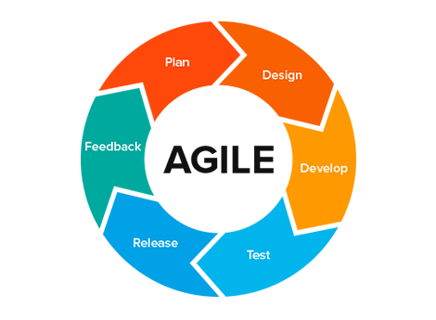

Scrum Framework
Scrum is a popular framework built on top of Agile. Its core parts include:
- Sprint: A short, fixed time period (usually 2 weeks) to finish a specific set of work.
- Sprint Backlog: The list of tasks and user stories chosen to be completed during the current sprint.
- Daily Scrum: A quick, 15-minute daily meeting where the team syncs up on progress and plans the next 24 hours of work.
- Sprint Retrospective: A wrap-up meeting at the end of a sprint where the team talks about what went well and how they can improve next time.
- Scrum Roles: The key team positions, including the Product Owner (manages the task list and priorities), the Scrum Master (helps the team follow Scrum and removes roadblocks), and the Developers/Testers.
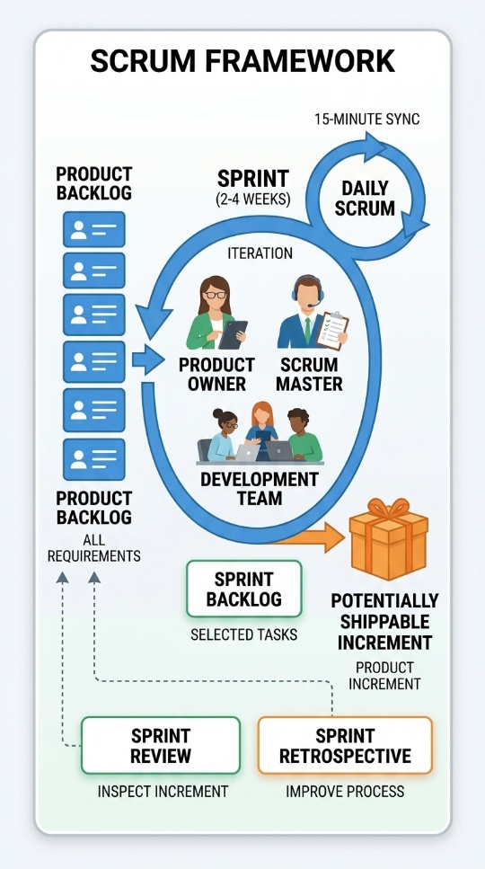

Basics About Jira
Modern Jira is built around three core concepts:
- Issue: Anything created and tracked in Jira—such as a task, bug, user story, or improvement.
- Project: A collection of related issues.
- Workflow: The series of steps an issue goes through from start to finish. For example, a standard workflow moves an issue from To Do, to In Progress, and finally to Done.

Jira Sprints
A sprint (or iteration) is a short, fixed period of time (usually two weeks for beginners) where the team builds and delivers a working piece of the product. Sprints are used on Scrum boards to help teams get regular feedback.

Creating a Sprint
- Go to the Backlog of your Scrum project.
- Click Create sprint at the top of the backlog.

Adding Issues to a Sprint
You can add tasks to a sprint using these simple methods:
- Drag and Drop: In the backlog, simply drag and drop issues into the sprint.
- Multi-Select: Hold Shift or Ctrl, select multiple issues, right-click, and assign them to the sprint.
- Direct Creation: Create a new issue directly inside an active sprint on your board.
- Inline Editing: Open any issue and type or select the sprint name directly in the Sprint field.

Opening JIRA
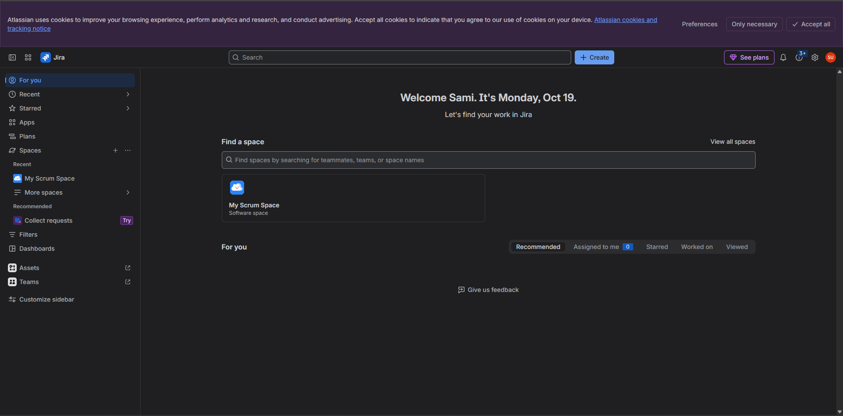
Login into JIRA using Email and Password

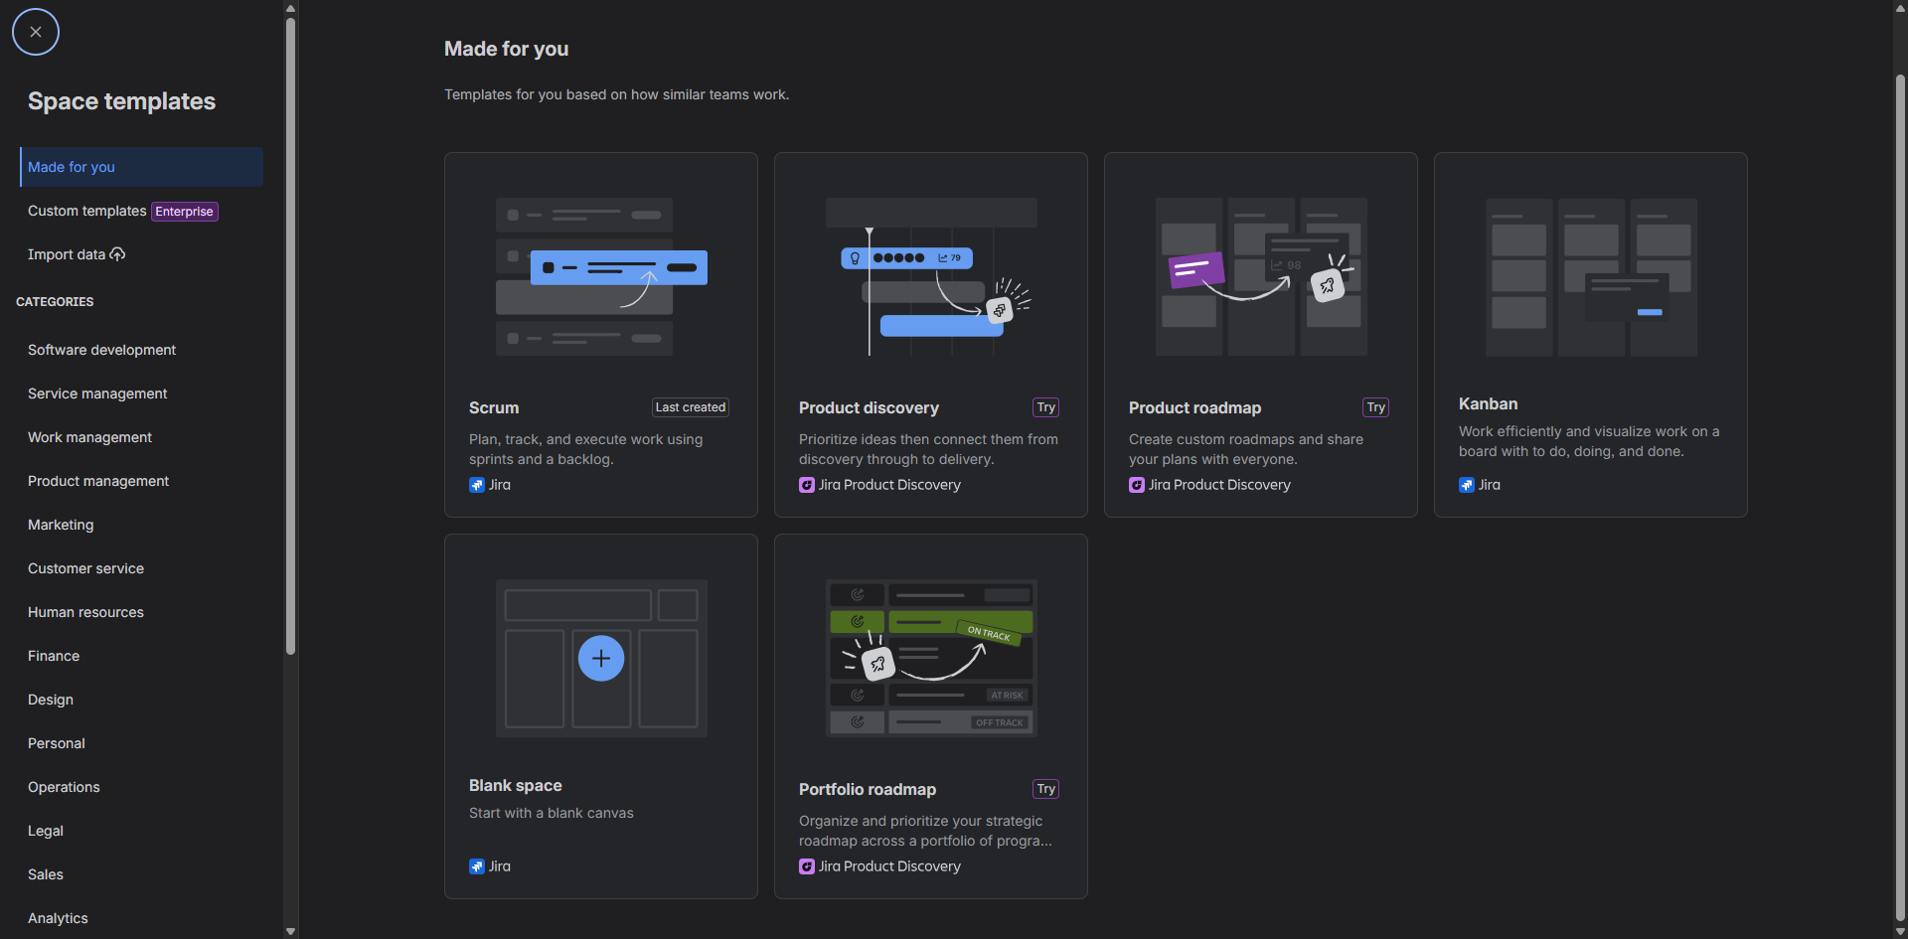
You can create a new space by clicking the + icon in front of Spaces

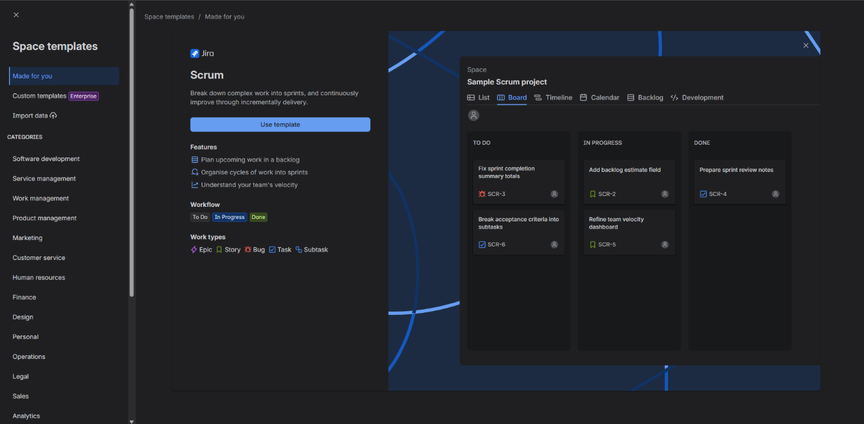
Click on Scrum, you’ll get this screen.

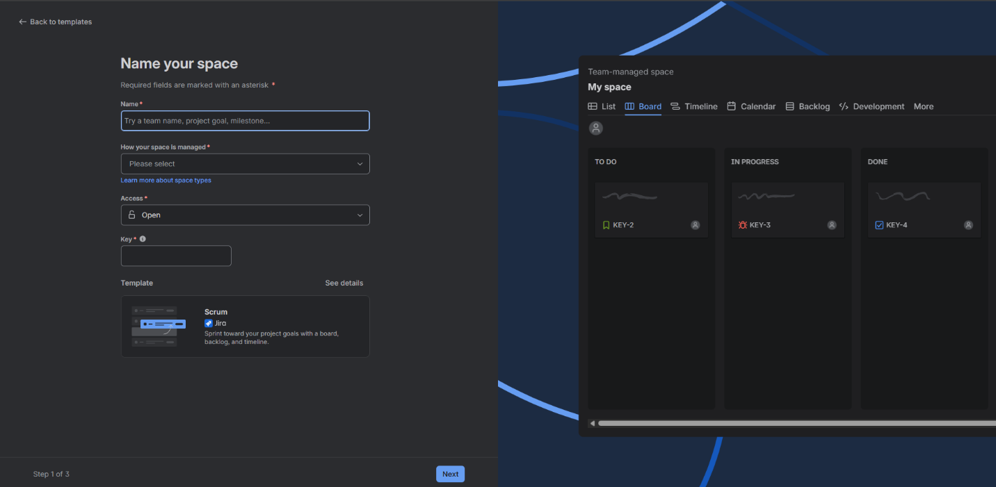
Click “Use template”. Adjust the settings according to your needs.

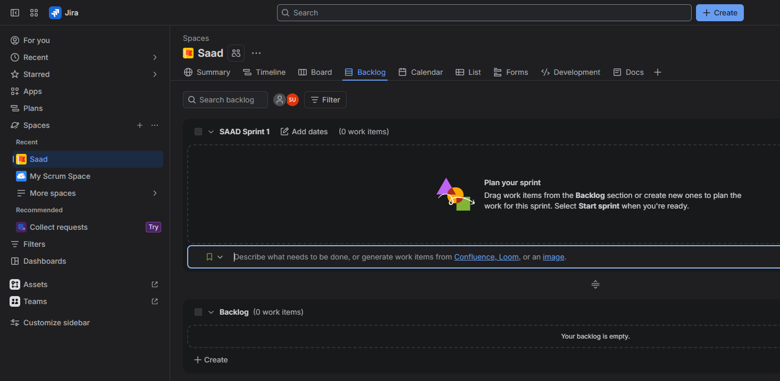
Your sprint space is created

Creating Epic in Scrum

Click on “+ Create” button

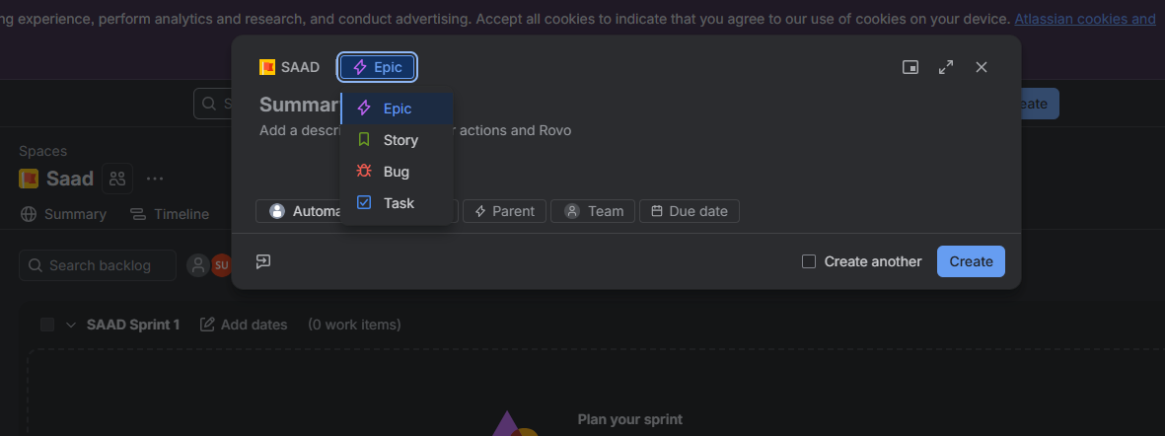

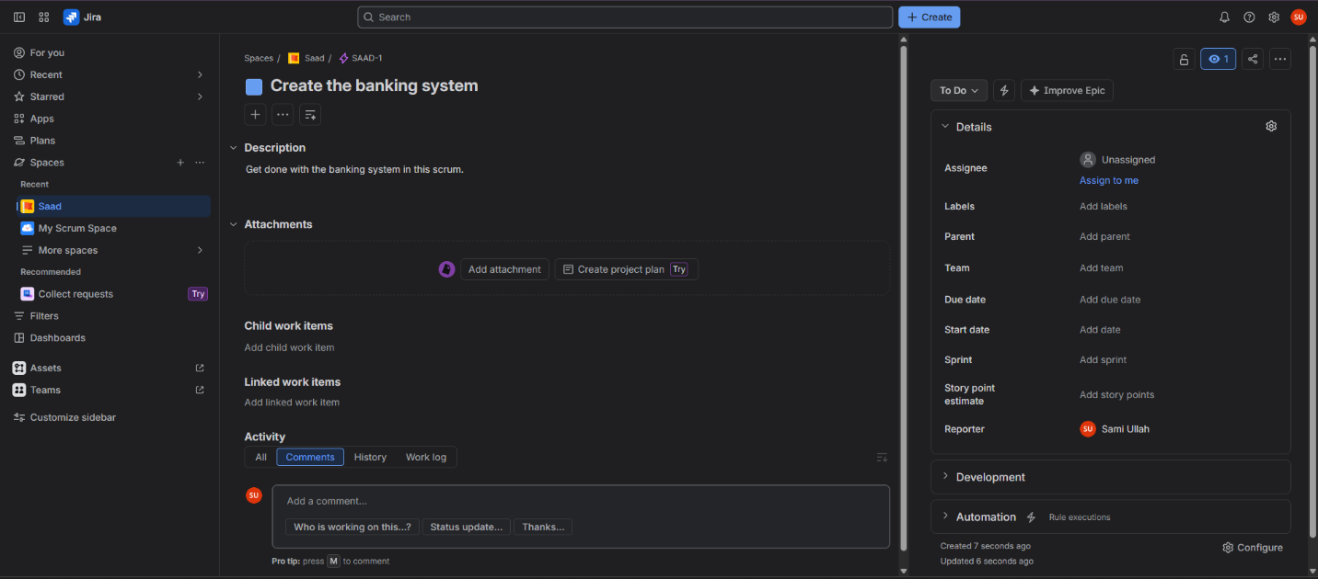
The Epic is created

